SIMATS ENGINEERING

ASSESSMENT TOOL 3

COURSE NAME: Artificial Intelligence COURSE CODE: CSA17

COURSE OUTCOME COVERED

CO2: Experiment search and game-solving techniques such as Greedy Search, A*, CSP, Minimax, and Alpha-Beta pruning with heuristic functions for solving complex AI problems efficiently. (BL3)

Assessment Tool Weightage: 40%

Duration: 1 Hour
QUESTIONS: 3 Total Marks:30

Annexure A

Dry Run Evaluation

Code of Conduct:
I THODETI DEEPESH (Name / Reg No) certify that this submission is my original work and that I have adhered to the guidelines specified for this assessment.
I understand that any violation of academic integrity rules will result in disciplinary action.

Signature of the student:
THODETI DEEPESH

Annexure A

Dry Run Evaluation
- Question 1 – Breadth-First Search (BFS) Consider the following graph: A
/ \

B C
/ \ / \

D E F G

Task: Starting from node A, perform a Breadth-First Search (BFS). Complete the following table.

Iteration | Queue | Visited Node
1
2
3
4
5
6
7

Questions:

  - Write the BFS traversal order.
  - Show the queue contents after each iteration.

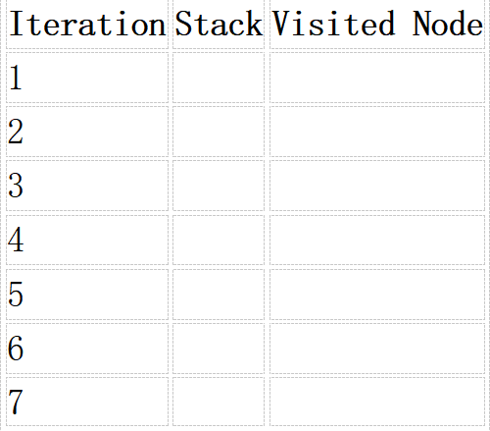
- Depth-First Search (DFS) Using the same graph,

A
/ \

B C
/ \ / \

D E F G
Perform Depth-First Search (DFS) starting from A. Complete the table.
- Initial State : 1 3 6
5 0 2
4 7 8

Goal State :
1 2 3
4 5 6
7 8 0

Task
Trace Breadth-First Search (BFS) until the goal state is reached. Fill in the table.
Iteration | Current State | Queue Before Expansion | Queue After Expansion
1
2
3
4
5

Questions

- Which node is expanded in each iteration?
- How many states are generated in total?
- Write the complete solution path from the initial state to the goal state.
- Why does BFS always find the shortest solution in an unweighted 8-puzzle problem?

OUTPUT:

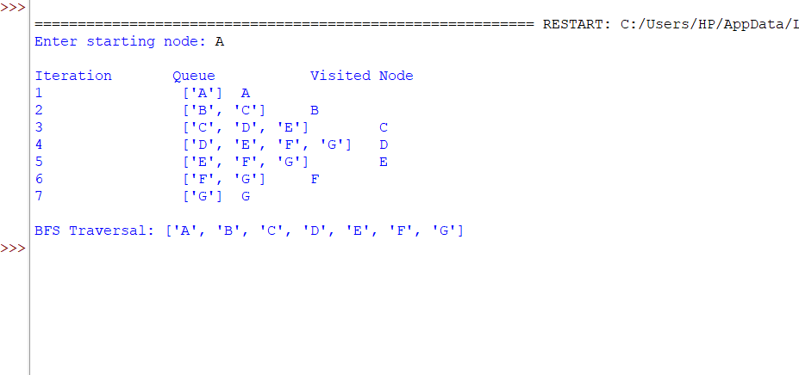

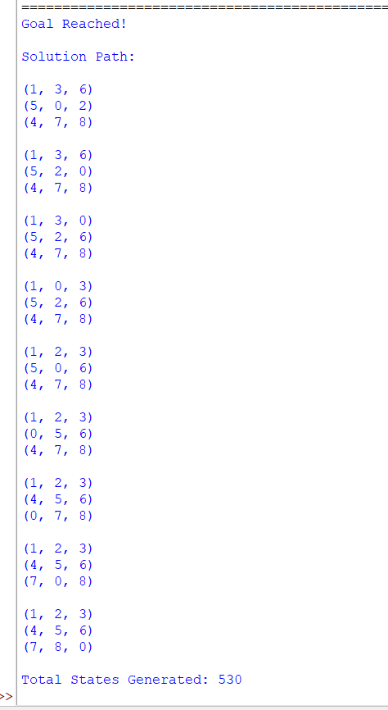
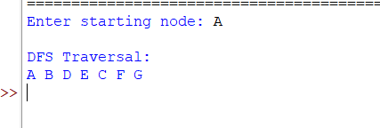

RUBRICS FOR CALCULATIO

RUBRICS FOR CALCULATION

Criteria | Weightage (%) | Level 4 –  Exemplary (4) | Level 3 –  Proficient (3) | Level 2 –  Developing (2) | Level 1 –  Beginning (1)
Understandi ng of Search Problem | 20 | Clearly understands the search problem, initial state, goal state, and search  strategy. | Understands the problem with minor misunderstandin  gs. | Demonstrates partial understanding of the search  problem. | Shows little or no understanding of the search  problem.
Criteria | Weightage  (%) | Level 4 –  Exemplary (4) | Level 3 –  Proficient (3) | Level 2 –  Developing (2) | Level 1 –  Beginning (1)
State Expansion and Dry Run Execution | 30 | Correctly traces every iteration, expands nodes accurately, and maintains the Queue/Stack/Priority Queue without errors. | Performs most iterations correctly with minor mistakes in state expansion or  data structure updates. | Performs only some iterations correctly; several errors in tracing or node expansion. | Unable to correctly perform the dry run or expand states.
Application of Search Algorithm | 20 | Applies the selected algorithm (BFS/DFS/UCS)  correctly, following all algorithmic rules. | Applies the algorithm correctly with a few procedural errors. | Applies only basic algorithm steps with noticeable mistakes. | Fails to apply the correct search algorithm.
Accuracy of Solution Path | 20 | Identifies the correct traversal order/solution path and goal state with  proper justification. | Solution path is mostly correct with minor errors. | Partially correct solution path; goal may not be reached correctly. | Incorrect or incomplete solution path.
Presentation and Logical Reasoning | 10 | Queue/Stack/Priority Queue updates, state diagrams, and explanations are neat, organized, and logically presented. | Presentation is clear with minor organizational issues. | Limited explanation and organization; reasoning is partially clear. | Poor presentation with unclear or missing reasoning.

